Impact of U.S. Financial Crisis on the European Union

Money Banking and Finance Essay

By – Sarthak Dalmia

ID – 2018B3A70290G

Introduction

The global financial crisis is considered one the most devastating economic shock, second to only the likes of the Great Depression of 1929. In US, the unemployment rose to 10% in October 2009. The subsequent stock market crash wiped out nearly $8 trillion in value between late 2007 and 2009. With the housing market crash, US households lost about $9.8 trillion in wealth as their house values plummeted and their retirement accounts disappeared.[2] The following graph shows GDP growth rate across the world over the last 40 years. 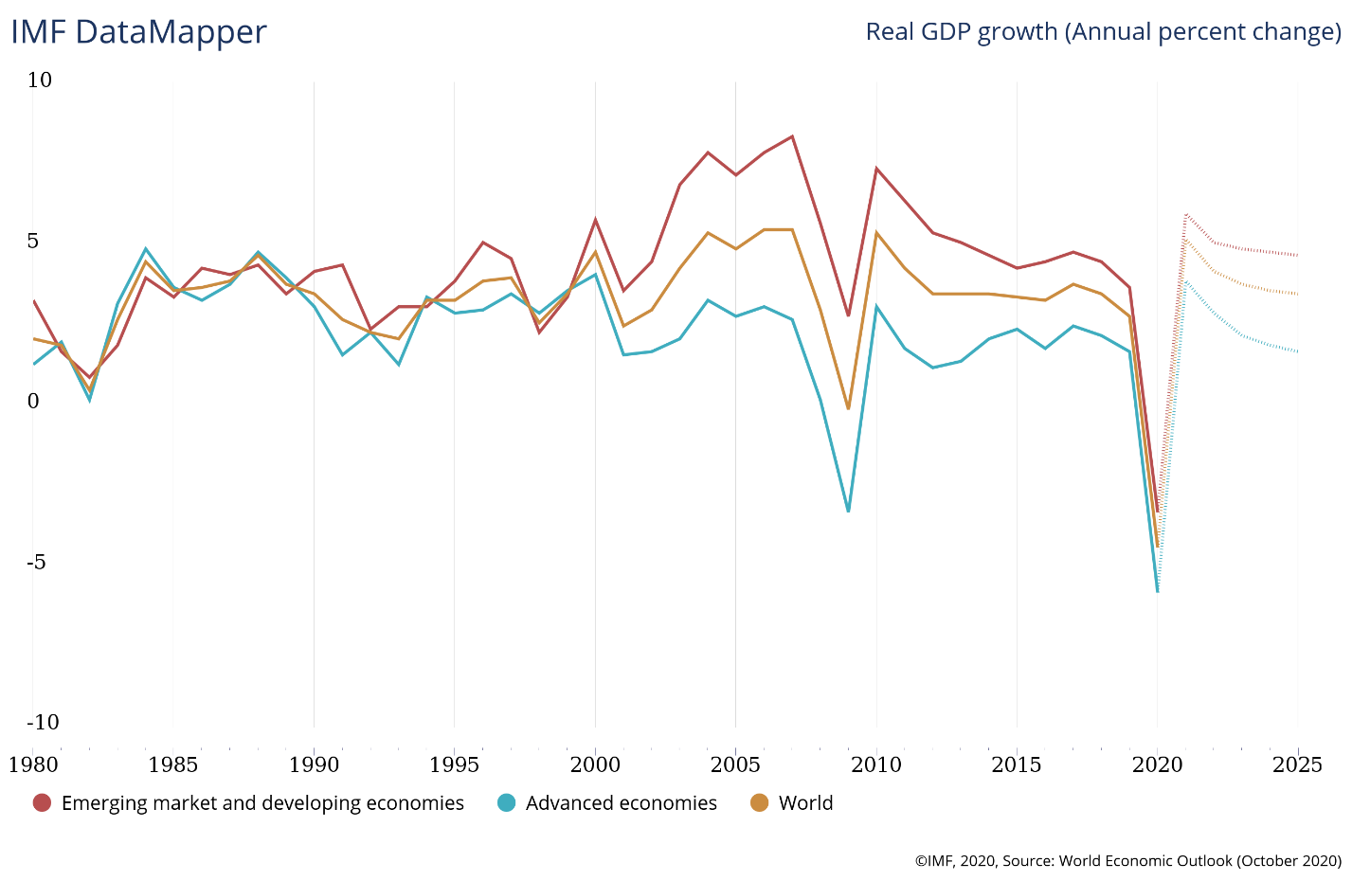

Due to globalization and an increasingly influential position of the US in the global financial system the crisis rippled through the entire world within months of the initial indication of the impending crisis in US. More than $2 trillion in global economic growth, nearly 4%, was lost between the pre-recession peak in Q2 of 2008 and low in Q1 of 2009 according the Moody’s Analytics.[2]

The housing market bubble was forming all over the world over the last decade. As the value of dollar plummeted with an increased pumping of money from the US government the value of dollar-denominated international securities like the Eurodollar bonds also plummeted. Many long-standing banks of the European union like the Northern Rock of UK had suffered huge losses, as for support these banks had to ask the national (Bank of England) and international banks for immediate support as lender of last resort. Thus, when the subprime mortgage crisis hit the world those markets restricted their lending from anything over-exposed to the housing markets.[1] This triggered bank runs across the world and a subsequent financial crisis.

Some problems with the International Finance Market

International bank is financial entity offering financial services, such as loans, lending opportunities and payment accounts to foreign companies and individuals. These types of banks get there funding from international money market (IMM), which consists of sub-markets such as the foreign exchange market, the international securities market (treasury bills, bonds, equities) and international loans.[3] There are various types of securities dealt worldwide like Foreign bonds, Eurobonds, and Brady bonds. This increased dependency on IMM’s of the international banks as compared to domestic banks (which depend relatively more on customer deposits) makes them susceptible to changes in foreign currency values and economic conditions of the countries they are invested in. [3]

Depreciation of dollars results in deterioration of balance sheets of banks consisting of dollar bonds. This reduction in assets value reduces the net worth of the bank leading to various other known issues.[1] Furthermore, going by the balance of payments theory changes trade deficit and surplus affects the exchange rates which results in the above-mentioned problems. Due to an increased scale of the system, there is an increase in the asymmetric information. [1] Expectations of increase in economic growth generally implies inflation and appreciation of local currency.[1] This thus affects the ability of banks to manage their asset liquidity due to updated demands of the securities.[1]

How was Europe affected by the crisis?

Each country in the European Union was affected differently by the financial crisis. When the housing bubble burst in 2007, default rates on mortgage loans increased rapidly across the world. This triggered a re-evaluation of asset-backed securities. Due to the decreased demand on asset-backed securities, the pressure on the lending banks resulted in write-offs in the bank dealing in mortgage-backed securities and CDOs causing huge losses. This resulted in liquidity crunch in big banks like the Santander Bank in Spain, Northern Rock in England, and banks in the US. Usually banks with a deficit of funds would borrow from international banks but the liquidity crunch resulted in high interbank lending rates which made it harder to get funds.[1] In Spain, the lack of standard policies to follow the International Accounting Standards Board standards made it easier for banks to hide losses from their balance sheet which contributed to the problem of asymmetric information.

Countries like Germany had mostly constant housing price over the last decade.[5] Germany followed three-pillar banking structure which allows each bank the ability to provide different services like mortgage loans, savings accounts etc. The banking structure helped to reduce the effect of the first wave of crisis (namely the defaults on mortgage loans) compared to some other countries.[5] The insolvency of Lehman Brothers in 2008 resulted in the second wave of the crisis.[1] The damaged trust between banks resulted in a greater difficulty in refinancing of a major bank known as the Deutsche Industriebank AG.[1] The overall situation made the recession period deep but relatively short lived in Germany.[5]

The special case of Greece

The downfall of Greece was due to systematic tax-evasion. Wealthier workers under-reported their incomes to avoid taxes [1] resulting in huge trade and fiscal deficits. Further, the government of Greece falsified its budget to meet the Maastricht Treaty conditions (limits government deficits under 3% and public debt under 60% of the GDP) to enter the European Union. Despite the growth in Greece’s economy the government did not correct the systemic problem of the fiscal deficit.[8] This growth was funded not by tax-payers money but by low rate borrowing from fellow European Union countries. This worsened Greece’s debt position exposing the true nature of Greece’s financial situation. The US rating agencies rated Greece bonds to junk in 2010, further pushing the country into liquidity crisis.[1] Greece was forced to ask for bailout from ECB which was conditional on the country undergoing some fiscal reforms. The country finally defaulted in its debt paving the way for the European Sovereign Debt Crisis.[1]

The Case of Northern Rock Bank

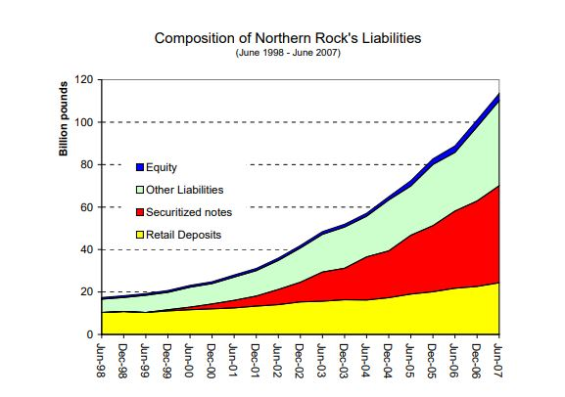The Northern Bank of United Kingdom was the first one to report liquidity problems during the crisis in the European Union. In the last decade before the crisis the bank expanded aggressively [1] by increased liberalization in regulation in finance markets all over the world.[1] The bank had financed most of its growth via international money market (IMM) instruments such as asset-backed securities.[1] Shadow banking system refers to group of financial intermediaries which creates credit across the global financial system without using traditional deposits, thus not subject to normal regulation. This played a major role in the credit boom that happened all over the world.[1] Thus, when the housing markets went bust anything overexposed to the housing market had no funds. The UK’s Special Liquidity Scheme (SLS) came into effect. The SLS enabled banks to swap high-quality non-liquid bills for the highly liquid UK Treasury bills. These can then be used as collateral by banks to borrow cash.[6] On 14 September 2007, the bank’s perilous position was made public which triggered the first UK bank run in over 150 years. The bank’s share price fell from an all-time high in February 2007 by 77% to September 2007. Alistair Darling, the Chancellor, reassured the customers that government will return all existing deposits on 17 September.[6] The method of dealing with bank failure in UK was lackluster in two following ways: First, GBP2,000 will be reimbursed; Second, if the bank becomes insolvent and put into administration all deposits would be frozen. This further aggravated the bank run.[1]

*Source*: <http://citeseerx.ist.psu.edu/viewdoc/download?doi=10.1.1.637.8526&rep=rep1&type=pdf>

*Source: http://www.n-ram.co.uk/~/media/Files/N/NRAM-PLC/results-presentations/halfyearresults080801.pdf*

With the support from Bank of England for a few months, the bank was finally nationalized in February 2008. When the Company Virgin Money acquired Northern Rock in 2012, the headline read: “6,500 jobs created and £175m spent on the social fabric of this region – we should not be deserting them now…”.[7] This call to the public worked and people were lining up to open accounts in the bank rather than closing them. The bank is still going strong with over 3000 employees and re-payments and sale of Northern Rock to Virgin Money would eventually sum up to a profit between £8bn to £11bn in taxpayers’ money.[7]

Conclusion

International finance markets are both a boon and a bane to the global financial health. On one hand it provides huge and easy source of funding thus promoting growth at a level not possible by mere local financing solutions. On the other hand, the high interconnection between various big banks and different economies make the system susceptible to greater fluctuations with variation in any of these components. With the usual interest rate risk, now an additional exchange rate risk is there. Credit crunch in one country, can lead to a cascading effect on other global economies by making it harder for international banks to manage liquidity by interbank loans. As observed, several long-standing banks like Northern Rock succumbed to liquidity crunch. The global financial crisis has the root problem of de-regulation of the finance market and the continual decrement of Feds fund rate in the US by the Federal Reserve Bank. This further highlights the problem. To avoid similar crisis in the future, I suggest that shadow banking should be more strictly regulated. Large banks should be monitored more aggressively for moral hazard.[1] Private banks should also have strict guidelines regarding the risk structure of the firm’s investment and the liquidity management.[1] The fall of Northern Rock teaches us that diversification of assets in a bank’s balance sheet is not a bad idea.[1] After extensive studies regarding the crisis by world’s leading economists, we cannot be 100% certain about the problems leading to the crisis. World governments have reformed their financial to avoid future financial crisis but that does not absolve the world of another Global financial crisis in the future.

References and Data Sources

[1]Dalmia, Sarthak (2020): Impact of the U.S. financial crisis on the European Union

[2]<https://www.washingtonpost.com/business/economy/a-guide-to-the-financial-crisis--10-years-later/2018/09/10/114b76ba-af10-11e8-a20b-5f4f84429666_story.html>

[3]<https://money.howstuffworks.com/personal-finance/banking/international-banking.htm#:~:text=An%20international%20bank%20is%20a,lending%20opportunities%2C%20to%20foreign%20clients.&text=Companies%20do%20business%20with%20international,which%20can%20be%20quite%20costly>.

[4]<https://www.investopedia.com/terms/i/internationalbond.asp>

[5]Bleuel, Hans-H. (2009) : The German banking system and the global financial crisis: Causes, developments and policy responses, Düsseldorf Working Papers in Applied Management and Economics, No. 8, Fachhochschule Düsseldorf, Fachbereich Wirtschaft, Düsseldorf, <http://nbn-resolving.de/urn:nbn:de:hbz:due62-opus-5116>

[6]<https://spark.adobe.com/page/DAlRb7HdWiHqA/>

[7]<https://www.chroniclelive.co.uk/business/business-news/northern-rock-anniversary-how-crisis-13614085>